

**NATIONAL CERTIFICATE**

# INDUSTRIAL INSTRUMENTS N5

(8080205)

**22 April 2021 (X-paper)**

**09:00–12:00**

**Drawing instruments may be used.**

**This question paper consists of 6 pages and a formula sheet of 2 pages.**

297Q1A2122



Please turn over

## DEPARTMENT OF HIGHER EDUCATION AND TRAINING

**REPUBLIC OF SOUTH AFRICA**

NATIONAL CERTIFICATE

INDUSTRIAL INSTRUMENTS N5

TIME: 3 HOURS

MARKS: 100

### INSTRUCTIONS AND INFORMATION

1. Answer all the questions.

1. Read all the questions carefully.

1. Number the answers according to the numbering system used in this question paper.

1. Use only a black or blue pen.

1. Write neatly and legibly.

**SECTION A: FLOW MEASUREMENTS**

### QUESTION 1

1.1 Suppose the flow rate of a weak acid solution is measured using a magnetic flowmeter. The conductivity of the acid is well within the acceptable range for this meter which means it works well. Now suppose the acid solution grows in strength (greater acid concentration). This will increase the conductivity of the solution, because there are now more ions available to carry an electric current.

What effect will this have on the calibration of the magnetic flowmeter? Must the flowmeter be recalibrated to properly measure the acid flow again? (6)



1.2 Explain each of the FOUR energies that exist in a pipe.  (4 × 2) (8)

1.3 Explain the square-root problem with reference to differential pressure and

flow. (4)

1.4 What is an integral orifice differential pressure cell and where can it be used? (4)

### [22]





### QUESTION 2

B

T

1

T

2

A

C

D

### FIGURE 1

2.1 Label FIGURE 1 by writing the answer next to the letter (A–D) in the

ANSWER BOOK. (4 × 1) (4)

 

2.2 Which type of flowmeter is shown in FIGURE 1? (1)

2.3 Explain the disadvantage of the flowmeter in FIGURE 1. (2)



2.4 Explain how to overcome the problem explained in QUESTION 2.3. (2)

2.5 Briefly explain how the flowmeter in FIGURE 1 measures the mass flow rate. (2)

**[11]**

**TOTAL SECTION A:**   **33**

**SECTION B: DENSITY, HUMIDITY AND VISCOSITY**

### QUESTION 3

3.1 Explain, with the aid of a sketch, the operating principle of a capacitive

hygrometer. (8)

3.2 Explain the operating principle of a common hand-held-type hydrometer. (4)



3.3 List THREE factors affecting the specific gravity of a liquid.  (3)

3.4 Explain an impedance hygrometer under each of the headings:

3.4.1 Sampling system (2)

3.4.2 Limitations (4)

3.5 State Henry's law as it applies to moisture measurement. (2)

3.6 State FIVE points to observe when using a falling piston viscometer. (5)

**[28]**

**TOTAL SECTION B:**   **28**

**SECTION C: pH MEASUREMENT**

**QUESTION 4**

4.1

Explain the

cleaning

of pH electrodes.

(9)

4.2

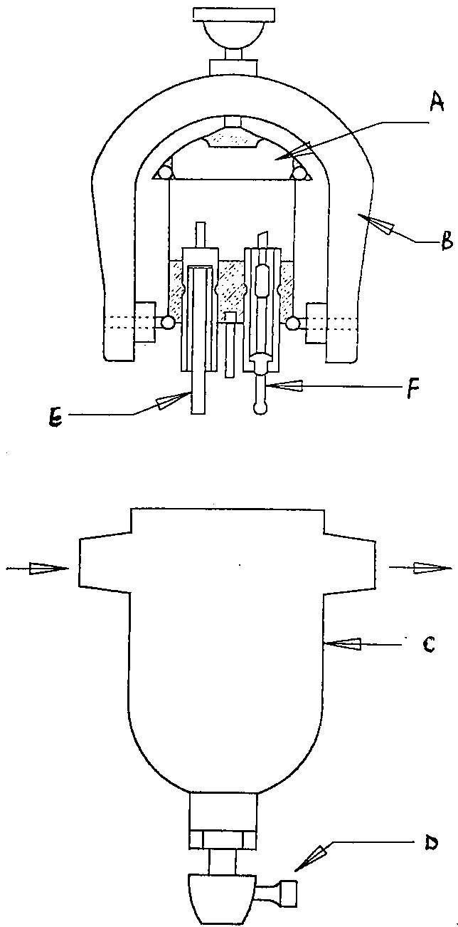

### FIGURE 2

4.2.1 Which type of electrode system used in industrial processes is

shown in FIGURE 2? (1)

4.2.2 Label the electrode system by writing the answer next to the letter

 (A–F) in the ANSWER BOOK. (6 × 1) (6)

4.3 Which precaution should kept in mind if the pH-sensitive electrode is operated

in or near an electrical field? (2)

**[18]**

**TOTAL SECTION C:**   **18**

**SECTION D: AUTOMATIC CONTROL**

### QUESTION 5

5.1 Make a neat block diagram of PID controller. (10)

5.2 Explain the summarised effect upon loop performance of a three-term

controller. (5)

5.3 Make a fully labelled sketch of a typical two-position, differential-gap,

electrically operated control. (6)

### [21]

**TOTAL SECTION D:**  **21**

**GRAND TOTAL:**  **100**

### FORMULA SHEET

|  |  |  |
| --- | --- | --- |
| *W*  3592*CZ**Ed* 2 | *(h*) | *ρ* |
| *Q*  3592*CZ**Ed* 2 | *(h*) | *ρ* |

*Qg*  2238 *CZEd*2 (*h*/)

*m*  (*d* /*D*)2

*Rd* *W*/158*d*

*Rd*  *Q*/158*d*

*Rd*  *Qg*/986*d*

*E* 1/(1 *m*2) *W*  001252*CZ**Ed*2(*h*) *Rd*  354*W*/*d*

*Q*  001252*CZ**Ed*2(*h*/) *Rd*  354*Qd*/*d*

2 *E* 1/(1 *m*2) *m*  (*d*/*D*)

*W Q* ()

*N*  001252 *D*2 (*h*)  001252 *D*2 (*h*)

*mE*  *N*/*CZ*

#### CmEN/Z mECmE/C

*Rd*  354*W*  354*Q**D* (*m*) *D* (*m*)

*d*/*D* [(*mE*)2/1 (*mE*)2]

-1-

*W* 1252*Ud*2

*d* [*W*/1252*U*

*W Q* () *Qg* ()

*N*  2 (*h*)  3592 *D*2 (*h*)  2238 *D*2 (*h*)

3592 *D*

*mE**N*/*CZ*

*CmE**N*/*Z* *mE**CmE*/*C*

#### W Q Qg

*Rd*   

158*D* (*m*) 158*D* (*m*) 986*D* (*m*)

*d*/*D* [(*mE*)2/1 (*mE*)2]

*W* 1890*Ud*2(*P*) for critical flow

*d*  [*W*/1890*U* (*P*)] for critical flow

1 kPa = 102 mmWD = 102 mmWC

1. lb/ft3 = 16,0183 kg/m3

(*P*)for critical flow

(*P*)]for critical flow

Please turn over

-2-

Atmospheric pressure = 101,325 kPa

Gravitation acceleration = 9,81 m/s2

*D h kPa*

For *D* -tappings and flange tappings  27,2   27,2

1. *Pa kPa*

5

.

2

2

tan

15

8

*H*

*g*

*Q*

❑



3

.

2

3

2

*H*

*g*

*B*

*Q*

